2024 ADS Photo Contest
GRAND PRIZE WINNER
Hollyhill Honeygold
Kay Mackey
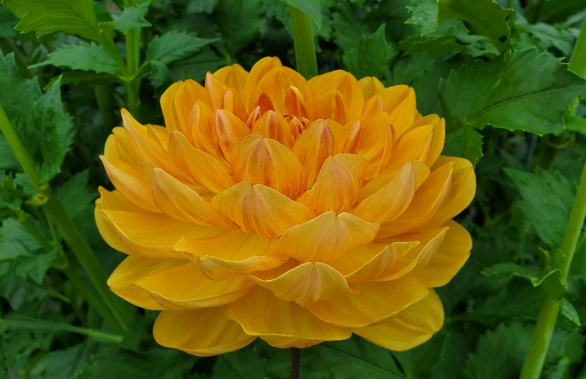

Class 1 – Undisseminated Dahlias/Seedlings
1st Place-S Molly-Sandy Boley
2nd Place-Kristine Albrecht
3rd Place-April Adams
HM-Kay Mackey

Class 2 – Dahlia Portrait—Portrait of a single cultivar
1st Place-HollyHill Honeygold-Kay Mackey, also Grand Prize Winner
2nd Place-Todd Imhoff
3rd Place-Irish Gnome-Mike Kangas
HM-Clearview Edie-Christine Tareen

Class 3 – Dahlia Blooms- More than one bloom or multiple cultivars
1st Place-Todd Imhoff
2nd Place-Clearview Cameron-Quamrun Eldridge
3rd Place-Courtney Solen
HM-Laia Solen

Class 4 – Dahlia Gardens
1st Place-Carrie Paquette
2nd Place-Richard Blake
3rd Place-Michael Burns
HM-Sunny Garden-Elijah Olson

Class 5 – Dahlia Shows and Personalities
1st Place-Laia Solen
2nd Place-Snohomish DS-Kay McMullin
3rd Place-Allison Lingbloom
HM-Arthur Haskins

Class 6 - Dahlia Arrangements- Cut flowers welcome
1st Place-Quamrun Eldridge
2nd Place-Lori Bell
3rd Place-Brian Moody
HM-Lenora Ayers

Class 7 - Dahlias and Kids
1st Place-Kristine Albrecht
2nd Place-Holly Ferris
3rd Place-Monti Cangiamilla
HM-Rhonda Cantrell

Class 8 - Dahlias and Critters- Insects, pets
1st Place-Hummer Suspended-Kathleen Brinkman
2nd Place-Sohini Rath
3rd Place-Robin Olexa
HM-Hide and Seek Froggy-Christine Tareen

Class 9 - Macro View - Up close photo
1st Place-Spiral-Alysia Obina
2nd Place-Renata Outerbridge
3rd Place-Shadow Droplets-Christine Tareen
HM-Bisected Novelty-Sandy Boley

Class 10 – Digital Darkroom - Have fun and experiment
1st Place-Julie E. Lanesey
2nd Place-Blue Dahlia-Anne Maria Jacobson
3rd Place-Quamrun Eldridge
HM-Erica Cheresh

