YOU’VE GOT SOME GALL!
By Martin Král
NOTE: This is an updated article that appeared in the 2022 Dahlias of Today

Social media platforms lately have received withering criticism for their propensity to distribute misinformation, offer an arena for conspiracies, and for (quite unsubtle) efforts to promote unproven remedies, along with their more clandestine mission for selling advertising through click bait video. This virtual world became more transparent as the ongoing pandemic limited personal interactions and stymied work or social group activities. Yet being able to exchange photos, videos, and other forms of communication nevertheless is very popular. What appeared recently with great frequency on dahlia-oriented Facebook pages were descriptions and photos of a malady these (mostly novice) growers encountered on their stock - irregular growth and tumors, some called galls.
The gardeners’ consternation was not mollified by other forum participants’ suggestions and remedies. Keep it? Throw the plant out? Disinfect tools? Neutralize the soil? For how long? Is this even gall or just normal growth? Good advice was hard to find, they discovered.

A GALLING EXPLANATION
So what is a gall? It is a plant disease resulting in growth abnormalities produced by foreign organisms, such as insects, mites, or through bacterial, fungal, or nematode infection. Galls form after compounds secreted by the organisms alter the plant’s normal form through aberrant cell creation or reproduction. Insect-caused galls often appear visibly on leaves, stems, buds, and fruits that then may serve as hosts to their eggs. The plant reacts by encapsulating the egg with a thick layer of cells, thus forming a gall. Other galls form abnormal growth high up in trees, such as witches’ brooms. Most prominent are unsightly leaf galls on many ornamental garden plants, but often they do not stifle plant growth.
Bacterial crown gall may affect both woody and herbaceous plants. The water-borne bacteria enter these through damaged tissue and then begin to transform the plant’s DNA through tumor-inducing plasmids. The infection is not limited to the immediate vicinity of the wound: In dahlias it may become systemic, although that research is not yet conclusive. Indeed, the study of galls still is under-explored today. The two forms of bacterial gall found in the large Compositae family - in which dahlias are just one of the favored hosts – are crown gall and leafy gall.

CROWN GALL (Rhizobium radiobacter)
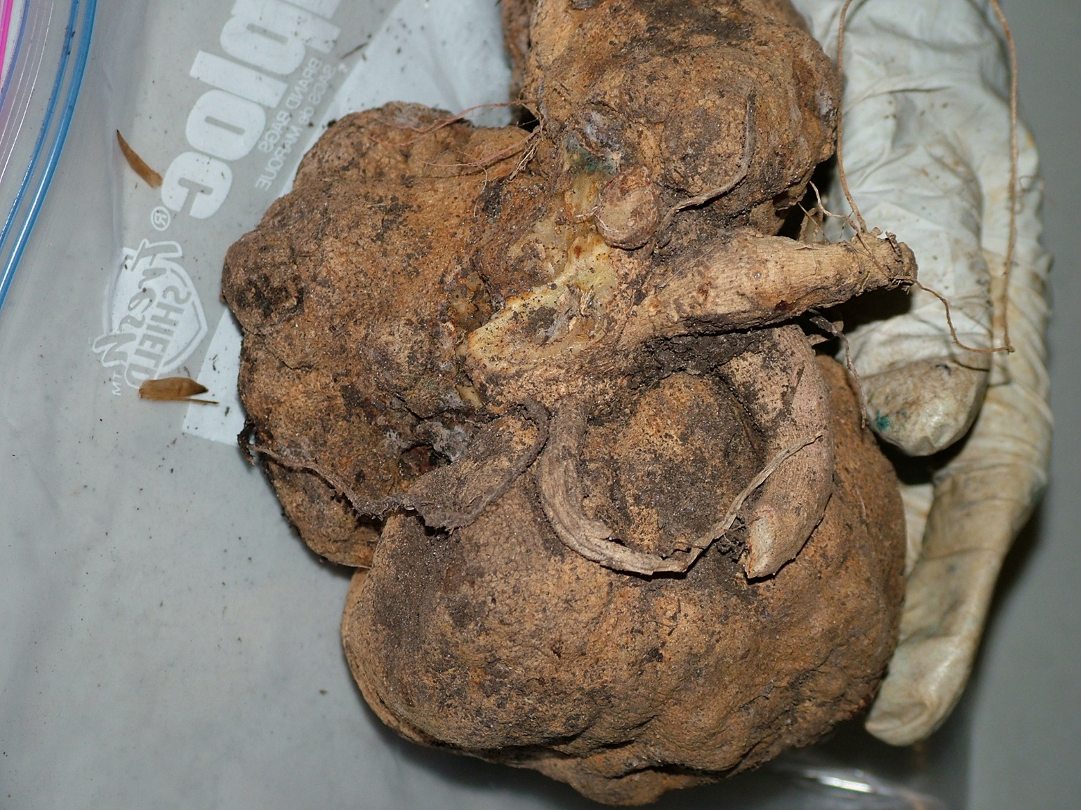
Also known as Agrobacterium tumefaciens, this bacterium manifests its infection by a rapid swelling of tissue or tumors below soil surface at the dahlia’s crown zone or basal stem. The bacterium enters a plant through injury caused by transplanting or cutting, but also from insects, and even wind, frost, or hail. Bacterial DNA combines with host plant DNA, transforming it, and eventually creates rapidly-multiplying tumor cells. The resulting growth is a mass of disorganized tissue, often with a knobby, rough-surfaced appearance. Initially beginning as small warts, the tumor also changes surface color from cream to a darker brown as the gall ages. Its shambolic cell structure inhibits water and food-conducting transmission, leading to a decline in plant health. The crown gall bacteria live on amino acid derivatives that the host plant can’t use, but which allow the bacterium to prosper. Most notably, a crown gall prevents new shoots from forming from the critical area of the crown zone. The dahlia grower will puzzle over that anomaly and perhaps try some remedy, but these symptoms won’t lead to proof until the root ball is unearthed in fall.

LEAFY GALL (Rhodococcus fascians)
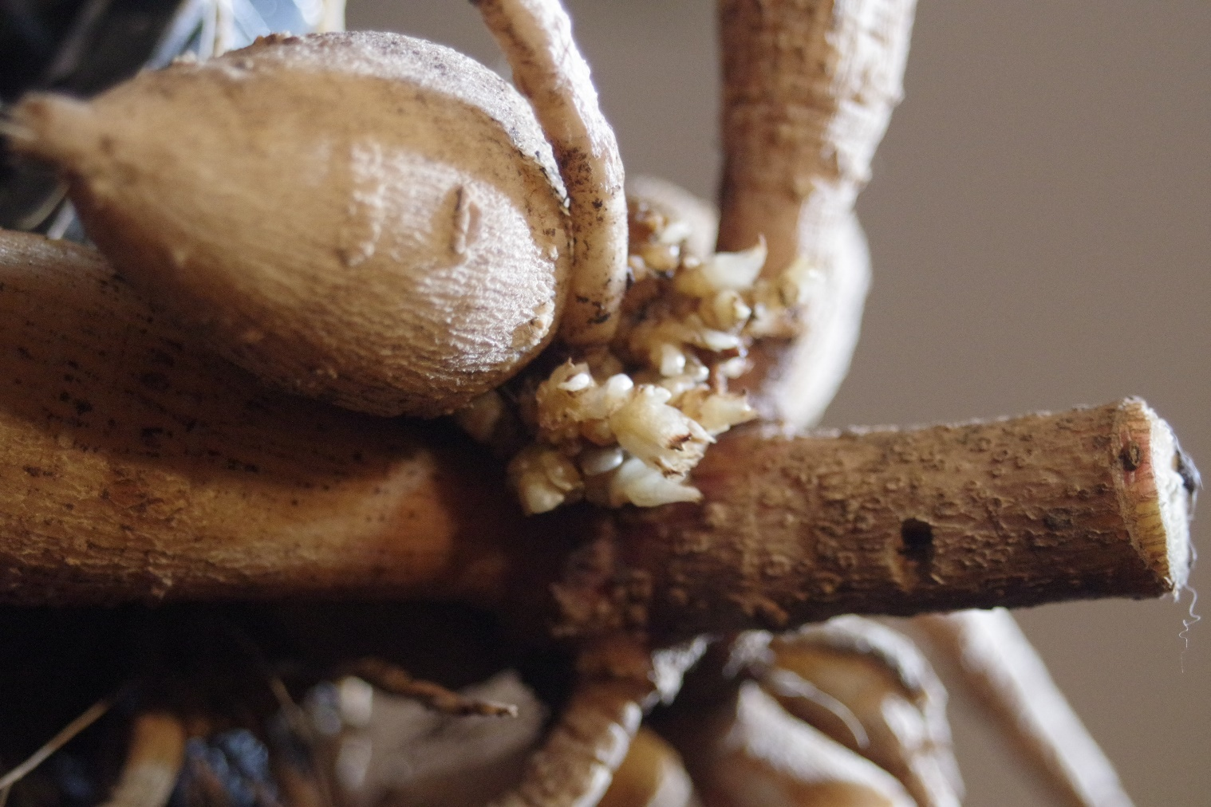
Not to be confused with leaf galls (see above), the leafy gall may not easily be detected by dahlia raisers. This fasciation or shoot proliferation results from bacteria carried within plant material and entering a plant through conditions that trigger an invasion of crown zone tissue. Leafy gall is not systemic, so it does not move into other plant parts or kill the plant. However, it disrupts normal plant hormone levels (its auxins or cytokinins function as growth regulators). Unable to move on their own, thus requiring water for transport, such bacteria nevertheless may impair the plant, or a large infestation may spread to neighboring plants. Also, the leafy gall’s dense structure retains water, encourages rot, and promotes botrytis fungus growth. Typically, the appearance of a mass of shoots, fused at their base, and one that does not develop into normal growth, indicates leafy gall. While an experienced dahlia grower can tell the difference between a healthy tuber and one infected with the disease by noting the appearance and number of growth eyes, most novices do not. Even ones desiring to take cuttings may be swayed by the superficially normal growth indicative of plant health.

RESEARCH AND REMEDY
Seminal work on gall diseases is being done by plant pathologist Prof. Melodie Putnam of Oregon State University. Director of the OSU Plant Clinic, she leads a team researching and testing plant diseases such as bacterial galls, and she has written dozens of scientific papers for more than twenty years on her findings. The Plant Clinic accepts submissions of suspected plant anomalies for analysis as part of its mission as a diagnostic facility and as Oregon’s Extension Service. She functions as advisor to Oregon’s large nursery industry but also answers questions from home gardeners.
In April 2021 Prof. Putnam sat down with Canadian interviewers in their Sustainable Flowers podcast and offered advice on dealing with dahlia gall diseases that was quite relevant to the topic here. The most striking statement in the interview was that: there is no cure for gall infection, so disease management is a non-starter. No treatment is successful on herbaceous plants like dahlias (although the industry uses Nogall and Galltrol, biological controls with some effect on woody plants). Moreover, the bacteria can winter over in the soil for more than a year, although they are heat sensitive. Control measures then include better sanitary approaches and soil exchange.
So here it goes:
- Obtain healthy stock from specialist dahlia nurseries. Trust, but verify.
- Avoid purchasing roots from mass market purveyors.
- Take cuttings only from good stock.
- Grow only those pot-rooted dahlias that show no evidence of leafy gall.
- Dip dividing or cutting tools regularly in Lysol, 70% ethanol, or a 1:5 bleach/ water solution.
- Rotate crops where infected dahlias were raised: plant vegetables, potatoes, or cover crops for a year.
- Sterilize compromised soil through solarization (covering soil with plastic tarp)
- If necessary, replace the soil with new.
- Destroy gall-infected plants by putting these in the trash, not in compost.

The recent rash of gall reports on social media points to a chronic problem that mass marketing dahlia purveyors ignore. Although it is not difficult to find virus-diseased dahlias even in conscientious dahlia nurseries, discovering gall disease requires more digging around. The harvesting by hand of clumps offers growers an opportunity to inspect and discard gall-infected plants. But machine harvesting and large-volume packaging of the roots, as is common with Dutch-grown dahlias, often permits infected dahlias to be processed, distributed, and then sold world-wide.

Ironically, I have the proof right in my hands. Last year (in order to take advantage of free shipping) I added a nice garden variety — Gudoshnik — to my spring order with K. van Bourgondien, a reputable Dutch wholesaler with whom I have shared a 35-year relationship. When the five clumps arrived, I trimmed them, discarding the usual broken tubers and root hairs. Then I gave away one and planted the rest. One of these turned out to have leafy gall - just look at the photo. That one went with the trash. The others ended up in the green recycling can, because, frankly, the variety looked better in the catalog than in my garden. And like others, I now sterilize my tools with the veterinary disinfectant Virkon-S.

For more detailed description and photos of gall diseases click here to view three instructive articles by biologist Nichole Warwick.

