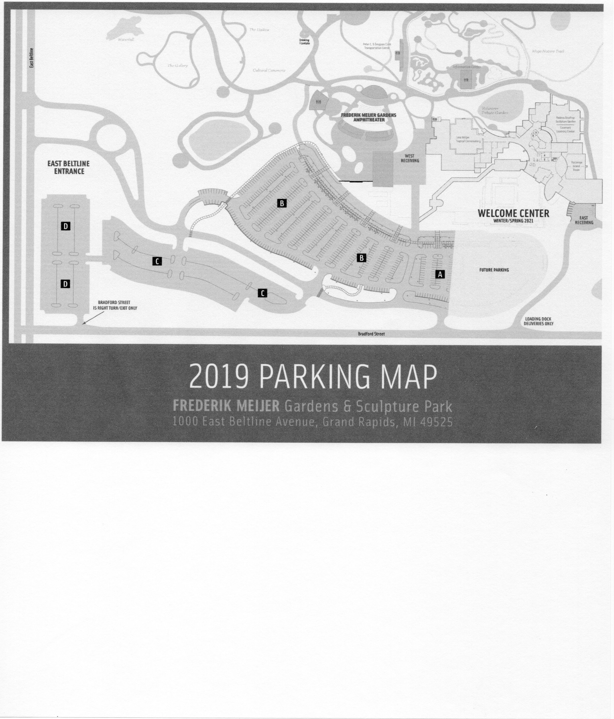

East Receiving

Bradford St

**Welcome to the 2019 National ADS Show!**

**Parking instructions** *(please excuse our progress!)*

Use the BRADFORD Street entrance, south of the main entrance

Blooms can be dropped off at the EAST RECEIVING dock.

-If you are prepping blooms after 5pm or before 9am, you may park your vehicle

Near the construction trailers along the service drive.

-If you are unloading during business hours 9-5, you will need to exit the loading

dock area, and go back to Bradford St and take the first right turn into the parking area.

If you enter the main gate, you will have to go through the parking area and exit to Bradford.

You can get to East Receiving from there.